Electromagnetism

Iran university of science and technology

**Mini Project: Electromagnetism**

modeling and simulating physics-based systems

COMSOL Project

Perform the following tasks for the two given figures.

**Figures:**

1. Two conducting plates filled with air, having a dielectric constant ϵ0​.

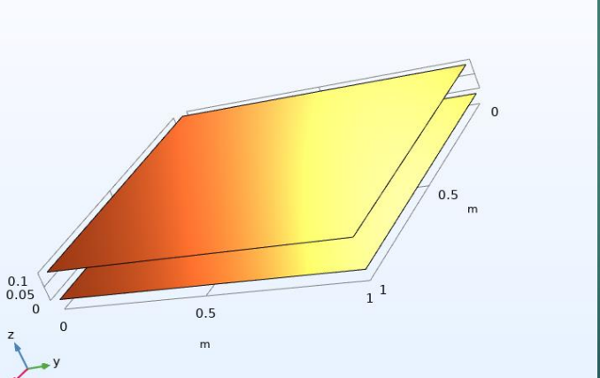

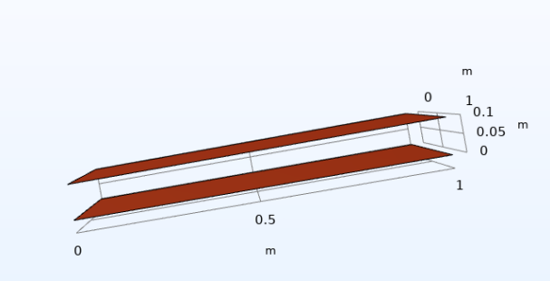

1. Two conducting cylindrical plates filled with mica, having a dielectric constant ϵr.

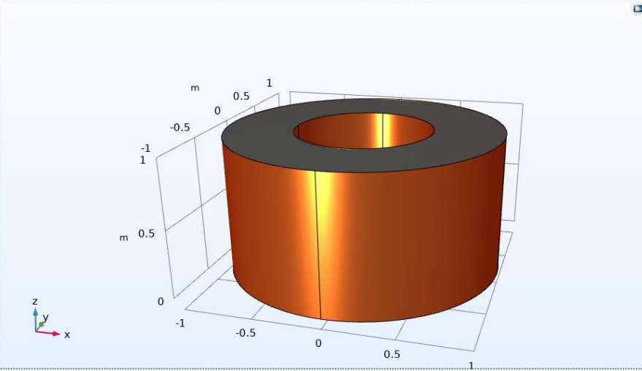

**Simulation Tasks:**

1. **Plotting the Potential and Electric Displacement:** The first task involves generating visualizations for the electric potential distribution (Volume) and the electric displacement (D) vector field (Volume) for each capacitor in the system. These plots should be created for both the interior and the exterior of the capacitors. The goal is to examine the distribution of electric potential and displacement fields within the capacitors and in the surrounding space. This step will help in understanding the behavior of the electric field both inside, where the capacitor plates and dielectric material are located, and outside, in the region surrounding the capacitors.
2. **Capacitance Calculation and Data Export:** The second task is to calculate the capacitance of the capacitor based on the simulation results. This involves analyzing the electrostatic configuration of the system and extracting the necessary data to compute the capacitance. After obtaining the capacitance value, the data should be exported for further analysis and comparison. It is essential to compare the simulated capacitance results with the theoretical values obtained through traditional formulas to validate the simulation and assess its accuracy.